0

0.1

0.2

0.3

0.4

0.5

0.6

0.7

0.8

0.9

1

0

0.2

0.4

0.6

0.8

1

1.2

1.4

Step Response

Time (sec)

Amplitude

**Fig. 5.13** Step response of *s*(*ss*++*z*1), *z* = 6.7273

1. plot the loci of



*K* 

*s*Π*ni*=−11(*s* + *pi*)

and determine the gain *K* that gives the pole *sd* using

 | | Π*ni*=−11|*sd* + *pi*| |

*K* = *sd* |*sd* + *a*2|Π*mi*=1|*sd* + *zi*

1. the controller gains are given by:

*K KD* = 

*k*

*KP* = *KD* (*a*1 + *a*2)

*KI* = *KDa*1*a*2

The corresponding discrete-time version of this controller, using the same transformation as for the proportional and integral controller, is given by:

*KPz*2 + *K*2*IT* + 2*KTD z* + *K*2*IT* + 2*KTD*  − *KP*

*C*(*z*) =

(*z* − 1)(*z* + 1)

This gives the relationship that links the control and the error at sample *k*:

*uk* = *uk*−2 + *aek* + *bek*−1 + *cek*−2 (5.4)

where *a* = *KP* + *K*2*IT* + 2*KTD* , *b* = *KIT* − 4*KTD* and *c* = *K*2*IT* + 2*KTD* − *KP*.

**Remark 5.4.4** *As we said regarding the schema for the discretization of the controller we can use here also the trapezoidal schema for the integral action and the backward schema for the derivative one. In this case we get:*

*u*(*k*) = *u*(*k* − 1) + *ae*(*k*) + *be*(*k* − 1) + *ce*(*k* − 2)

*with a* = *KP* + *KTDs* + *KI*2*Ts , b* = −*KP* − 2 *KTDs* + *KI*2*Ts , c* = *KTDs ;*

The lines that we should include in the control loop are:

compute the system’s error, e compute the control law using the controller expression save the present error and the present control send the control and wait for the next interrupt

**Example 5.4.4** *To show how this procedure can be used to design a proportional, integral and derivative controller, let us consider the following system with:*

3

*G*(*s*) = 

(*s* + 1)(*s* + 3)

*For this system we would like to guarantee that the steady state error for a step input is equal to zero with an overshoot less or equal to 5 % and a settling time about* 1*s. Following the steps of the previous procedure we get:*

1. *the slow pole in this case is equal to* −1 *and therefore, the parameter is then a*1 = 1*.*
2. *the dominant pole with the positive imaginary value is given by:*

*sd* 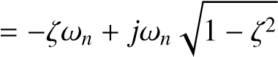

= −3 + 3*j*

1. *using this pole, we get since the pole* −1 *has been cancelled with the zero at* −*a*1*:*

α = π + ∠(−3 + 3*j*) + ∠(3*j*)

= 180 + 135 + 90

= 45

*which give the following value for the zero*

3

*a*2 = −3 + 

tan(45)

= −6

1. *the loci of the controlled system is given by Fig. 5.14, from which we concludethat K* = 2.99 *is the appropriate one that give the closest dominant poles and the damping ratio (sd* = −2.99 ± 2.99*j,* ζ = 0.707*, d* = 4.51 *% wn* = 4.23*).*

−20

−15

−10

−5

0

5

−5

−4

−3

−2

−1

0

1

2

3

4

5

0.997

0.4

0.66

0.82

0.9

0.945

0.974

0.99

0.997

2.5

5

7.5

10

12.5

15

17.5

0.4

0.66

0.82

0.9

0.945

0.974

0.99

Root Locus

Real Axis

Imaginary Axis

**Fig.5.14**

Rootlocusof

*s*

+

*a*

2



*s*

(

*s*

+

3)

,

*a*

2

=

6

1. *the controller gains are:*

|  |  |
| --- | --- |
| *KD* | = 0.9967 |
| *KP* | = 6.9769 |
| *KI* | = 5.9802 |

*The closed-loop transfer function is given by:*

*kKDs*2 + *kKPs* + *kKI*

*F*(*s*) = *s*3 + (4 + *kKD*) *s*2 + (3 + *kKP*) *s* + *kKI*

*The behavior of the closed-loop dynamics is illustrated in Fig. 5.15 The simulation results show the e*ffi*ciency of the designed controller.*

The phase lead controller can be used to approximate the proportional and derivative one. The transfer function of this controller is given by:

*aTs* + 1 *C*(*s*) = *KP* 

*Ts* + 1

where *KP*, *a* and *T* are parameters to be computed with *a* > 1.

This controller offers the advantage to improve the transient regime. This can be obtained if the placement of the pair pole/zero is well positioned since we can pull the asymptotic branches to get a smaller settling time.

0

0.5

1

1.5

2

2.5

3

0

0.2

0.4

0.6

0.8

1

1.2

1.4

Step Response

Time (sec)

Amplitude

**Fig.5.15**

Stepresponseof

*s*

+

*a*

2



*s*

(

*s*

+

3)

,

*a*

2

=

6

The following procedure can be used to design such controller (see [1]):

1. with the damping ratio and the settling time values, we can determine thedominant pole with the positive imaginary part, *sd*
2. by varying the system gain, try to get the desired dominant poles, if it is not possible, determine the contributionin angle of the pair pole/zero that the controller has to add
3. place the pole and the zero of the phase lead controller in order to compensatefor this desired angle. Among the possibilities that can be used in this case, we can place the zero at a value equal to the real part of the dominant poles and then using the angle condition we can determine the pole position.
4. determine the value for the controller gain in order to satisfy the error
5. check if the desired specifications are obtained. In case of negative answer replace the pair pole/zero of the controller and repeat the design procedure

**Example 5.4.5** *To show how the procedure of the phase lead controller can be applied, let us consider the position control for a dc motor driving a mechanical load as it was considered before. Let the dynamics be given by:*

2

*G*(*s*) = .

*s*(*s* + 2)

*Our goal in this example is to guarantee that the closed-loop system is stable, with a settling time at 5% equal to 0.5 s, an overshoot less or equal to 5% and having a zero error for a step input.*

*First of all notice that the time constant of the system is equal to* 0.5 *s which may give the best settling time at 5 % with a proportional controller equal to* 6 *s. Our requirement in regard to the settling time is far from this value and therefore a proportional controller is not su*ffi*cient for our case.*

*To respond to these specifications a phase lag controller can be used and its design can be done using the previous procedure.*

1. *based on the settling time and the overshoot requirements we get the following dominant pole with positive imaginary value:*

*sd* = −6 + 6*j*

*This desired poles can not be obtained by varying the gain of a proportional controller and therefore a design of a phase lead controller is needed. From this value for the dominant pole, we have:*

∠*G*(*sd*) = ∠(2) − ∠(−6 + 6*j*) − ∠(−5 + 6*j*)

= 0 − 135 − 123.6901 = −258.6901

*The controller can be designed to bring an angle* 258.6901 − 180 = 78.6901*. This is obtained if* ∠(*aTs* + 1) − ∠*Ts* + 1 = 78.6901

1. *following the method we used in the procedure, we get aT* =  *and therefore* ∠(*Ts* + 1) = 90 − 78.6901 = 11.3099*. This gives the location of the controller pole. Using now the following trigonometric relation we get:*

 tan(11.3099) = (*sd*)

1 *T*|

*which gives T* = 0.0278*. This in turn implies that a* = 61*T* = 5.9952*.*

1. *The open-loop transfer function of the compensated system is then given by:*

(*s* + 6)

*Gc*(*s*) = *K* *s*(*s* + 2)(*s* + 35.9712)

*which gives the following gain, K that corresponds to the desired pole sd:*

*s*

*K* = | *d*|*sd* + 2||*sd* + 35.9712|| = 311.7120

|*sd* + 6|

*The corresponding controller gain is KP* = *akK* = 25.9968*. The root locus of the compensated system is illustrated by Fig. 5.16.*

*The closed-loop transfer function with this controller is given by:*

2*aKP s* + *aT*1

*F*(*s*) = *s*3 + 2 + *T*1 *s*2 + *T*2 + 2*aKP* *s* + 2*KTP*

Root Locus

−40

−20

0

20

40

60

0.07

0.15

0.23

0.32

0.44

0.58

0.74

0.92

0.07

0.15

0.23

0.32

0.44

0.58

0.74

0.92

10

20

30

40

50

10

20

30

40

50

Imaginary Axis

−60

|  |  |  |  |  |  |
| --- | --- | --- | --- | --- | --- |
| −40 | −35 | −30 −25 −20 −15 −10 −5  Real Axis  *s*+ *aT*1  **Fig. 5.16** Root locus of 1 | 0 | 5 | 10 |

*s*(*s*+2)(*s*+ *T* )

*The behavior of the closed-loop dynamics is illustrated in Fig. 5.17*

*The simulation results show the e*ffi*ciency of the designed controller. It is clear that the performances are a little bit far from the desired ones. This is due to the place of the zero of the controller that we can from see from Fig. 5.16. We can play with this position by pushing it to the left and we will get what we want.*

**Remark 5.4.5** *It is important to notice that phase lead controller or the phase lag or the phase lead-lag controllers are not able to to make the error equal to zero since they can’t improve the type the system. But they can improve it if it is constant.*

The phase lag controller can be used to approximate the proportionaland integral one. Its task is to improve the steady state regime if it is well designed. The pair pole/zero of the controller is put close to the origin.The transfer function of this controller is given by:

*aTs* + 1 *C*(*s*) = *Kp* 

*Ts* + 1

where *KP*, *a* and *T* are parameters to be computed with *a* < 1.

0

0.2

0.4

0.6

0.8

1

1.2

1.4

1.6

1.8

2

0

0.2

0.4

0.6

0.8

1

1.2

1.4

Step Response

Time (sec)

Amplitude

2*aKP*(*s*+ *aT*1 )

**Fig. 5.17** Step response of *F*(*s*) = 3 1 2 2 2*K*

*s* +(2+ *T* )*s* +( *T* +2*aKP*)*s*+ *TP*

To have an idea of the design approach let us assume that the system to be controller is described by:





*G*(*s*) = *k*Π*ni*=1(*s* + *pi*)

where *k* is the gain, −*zi*,*i* = 1, · · · ,*m* and −*pi*,*i* = 1, · · · ,*n* are respectively the zeros and the poles of the system.

In fact, if we write the transfer function of the controller as: *s* + *z C*(*s*) = *KP* 

*s* + *p*

with *KP* = *aKp*, *z* = *aT*1 and *p* = *T*1 .

With the gain of the controller only, the constant error is given by:

Π*mi*=1*zi*



*K*1 = *kKP* Π*ni*=1*pi*

In order to improve the steady state error, we would get a constant error, *K*2, greater than *K*1. By introducing the zero and the pole of the controller this constant error is given by:

*z* Π*mi*=1*zi*



*K*2 = *kKP p* Π*ni*=1*pi*

Our desire is that the new pair of pole/zero of the controller doesn’t change the transient regime which is acceptable for the designer and the main goal is to change the steady state regime only by reducing the error. Using the expressions of *K*1 and *K*2, we get:

*K*1 *K*2

 *im*=1 *i* = *kKP* = Π*im*=1*z*

 Π *z z i*



Π*in*=1*pi p* Π*ni*=1*pi*

This implies that:

*p K*1

*a* = = < 1 *z K*2



Therefore, if we choose *T* in a way that the pole and the zero are close each other (to be cancelled in the open transfer function of the system), the open loop transfer function of the controlled system becomes:



*C*(*s*)*G*(*s*) = *kKP* Π*ni*=1(*s* + *pi*)

The idea we will use here is mainly based on the improvement of the steady state error. The following procedure can be used to design such controller (see [1]):

1. with the damping ratio and the settling time values, we can determine the poledominant with the positive imaginary part, *sd* and determine the gain that gives such poles. Compute the corresponding constant error.
2. determine the constant error, *K*1, with a proportional controller. Determine the constant error, *K*2 when the pole and the zero of the controller are considered. The parameter *a* of the controller is given by:

*K*1

*a* = 

*K*2 This parameter, *a* is also given by:

*p*

*a* = 

*z*

1. the value for *T* is chosen in a way to make the pole and the zero of the controller are close each other and at the same time close to the origin to improve the steady error. This choice will imply that the angle contribution of the controller is very small.
2. determine the gain, *K*¯*P*, using the following relation:

*K*¯*P* = ||*ssd* ++ *pz*||ΠΠ*nin*=1||*ssdd* ++ *pzii*||



*d i*=1

then detrmine the controller gain, *KP* by:

*K*¯*P*

*KP* = 

*ak*

1. check if the specifications are similar to the desired ones. In the case of negativeanswer adjust the placement of the pole and the zero of the controller and repeat the procedure

**Example 5.4.6** *To show how the procedure of the phase lag controller design can be applied, let us consider the position control for a dc motor driving a mechanical load as it was considered before. Let the dynamics be given by:*

2

*G*(*s*) = .

*s*(*s* + 2)

*Our goal in this example is to guarantee that the closed-loop system is stable, with a settling time at 5% equal to 3 s, an overshoot less or equal to 5% and having an error for a ramp input less or equal to 0.01.*

*To respond to these specifications a phase lag controller can be used and its design can be done using the previous procedure.*

1. *based on the settling time and the overshoot requirements we get the following dominant pole with positive imaginary value:*

*sd* = −1 + 1*j*

*The root locus the system with a proportional controller is given by Fig. 5.18.*

−2.5

−2

−1.5

−1

−0.5

0

0.5

−1.5

−1

−0.5

0

0.5

1

1.5

0.76

0.86

0.94

0.985

0.16

0.34

0.5

0.64

0.76

0.86

0.94

0.985

0.5

1

1.5

2

0.16

0.34

0.5

0.64

Root Locus

Real Axis

Imaginary Axis

**Fig.5.18**

Rootlocusof

1



*s*

(

*s*

+

2)

*The gain that gives this pair of poles is given by:*

*s*

*K*1 = | *d*||*sd* + 2| = 2.0

1 *This correspond to an error equal:*

*e*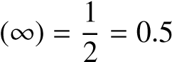

*which far from the desired one.*

1. *To get our error we need a constant K*2 *equal to 100. This implies that the factor a of the controller is given by:*

*K*1 2 *p*

*a* = = = 0.02 = 



*K*2 100 *z*

1. *since the pole and the zero of the controller have to be placed closed to eachother and close to the origin. If we place the zero at* −0.3 *which a pole for the controller at* −0.006 *using the fact that a* = *pz . The value of T can be computed using either the expression of the zero of the one of the pole. This gives T* = 166.6667*.*
2. *The open-loop transfer function of the compensated system is then given by:*

(*s* + 0.3) *Gc*(*s*) = *K* *s*(*s* + 2)(*s* + 0.006)

*which gives the following gain, K that corresponds to the desired pole sd:*

|*sd*|*sd* + 2||*sd* + 0.01||

*K* =  = 2.3102 |*sd* + 0.5|

*The corresponding controller gain is KP* = *akK* = 57.7549*. The root locus the system with a proportional controller is given by Fig. 5.19.*

*The closed-loop transfer function with this controller is given by:*

2*aKP s* + *aT*1

*F*(*s*) = *s*3 + 2 + *T*1 *s*2 + *T*2 + 2*aKP* *s* + 2*KTP*

*The behavior of the closed-loop dynamics is illustrated in Fig. 5.20*

*The root locus of the compensated system unfortunately doesn’t pass through the desired poles. The closed ones are sd* = −0.8082±1.14*j that corresponds to a gain K* = 2.56*, that gives a gain KP* = 64*. With this gain we get an overshoot approximately equal to 11 %.*

*The behavior of the closed-loop dynamics with this new setting is illustrated in Fig. 5.21*

**Remark 5.4.6** *It is important to notice that the overshoot is a little bit far from the desired one and it is the same for the settling time. This discrepancy is due to the presence of the zero that he introduce high overshot once it is close to the origin.*

Root Locus

Real Axis

Imaginary Axis

−2.5

−2

−1.5

−1

−0.5

0

0.5

−3

−2

−1

0

1

2

3

0.08

0.17

0.28

0.38

0.5

0.64

0.8

0.94

0.08

0.17

0.28

0.38

0.5

0.64

0.8

0.94

0.5

1

1.5

2

2.5

0.5

1

1.5

2

2.5

**Fig.5.19**

Rootlocusof

*s*

+

0

.

3



*s*

(

*s*

+

2)(

*s*

+

0

.

06)

*And also due to the fact the cancellation pole zero of the controller is not correct since the pole is a little bit far from the zero.*

The phase lead-lag controller is designed to approximate the PID controller. It has the advantage as the PID has to act on both the transient and the steady regimes. Previously we have seen how to design the phase lead controller and the phase lag controller. The first one is used to act on the transient while the second acts of the steady state regime.

The transfer function of this controller is given by:

*s* + *a*11*T*1 *s* + *a*21*T*2



*C*(*s*) = *KP s* + 11 *s* + *T*12

*T*

where *KP* is the controller gain, *a*1 with *a*1 > 1 and *T*1 are the parameter of the lead part, while *a*2 with *a*2 < 1 and *T*2 are the parameter of the phase lag part.

To design such controller, we use the approaches used to design separately the phase lead and the phase lag controller. First, without the phase lag controller, we design the phase lead controller to improve the transient regime. After, we add the phase lag controller to improve the steady state regime while keeping the transient regime as it was improved by the phase lead controller.

The following procedure procedure can be used to design the phase lead-lag controller:

**Fig. 5.20** Step response of *F*(*s*) = *s*3+(2+ *T*1 )2*saK*2+*P*((*T*2*s*++*aT*21*aK*)*P*)*s*+ 2*KTP*

1. without the phase lead-lag controller, see if with a proportional controller, wecan guarantee the desired performances.Analyze the system with a proportional controller and determine how much the transient regime has to be improved
2. design the phase lead controller (gain, pole and zero)
3. analyze the compensated system with a phase lead controller and determinehow much the steady state regime has to be improved
4. design the phase lag controller (gain, pole and zero)

0

1

2

3

4

5

6

7

8

9

10

0

0.2

0.4

0.6

0.8

1

1.2

1.4

Step Response

Time (sec)

Amplitude

1. check if the specifications are similar to the desired ones. In the case of negativeanswer adjust the placement of the pole and the zero of the controller and repeat the procedure

**Example 5.4.7** *To see how the procedure for the design of phase lead-lagcontroller applies, let us consider the following dynamical system:*

2

*G*(*s*) = 

*s*(*s* + 2)

*For this system with a proportional controller, the best settling time at 5 % we can obtain is equal to 3 s. We can also get an overshot less or equal to 5 %. The steady state error for a step input is equal to zero, while the one for a ramp is constant and*

**Fig. 5.21** Step response of *F*(*s*) = *s*3+(2+ *T*1 )2*saK*2+*P*((*T*2*s*++*aT*21*aK*)*P*)*s*+ 2*KTP*

*can be fixed by acting on the gain controller. A ”trade-o*ff *” between the overshoot and the steady state error has to be done. It is clear that the proportional controller will not give the good trade-o*ff*. The phase lead-lag controller will give the better one.*

*For this purpose let us assume that we desire the following specifications:*

1. *stable system in closed loop*
2. *an overshoot less or equal to 5 %*

0

1

2

3

4

5

6

7

8

9

10

0

0.2

0.4

0.6

0.8

1

1.2

1.4

Step Response

Time (sec)

Amplitude

1. *a settling time at 5 % about 2 s*
2. *a steady state error for a ramp input less or equal to 0.01*

*To design the phase lead-lag controller that provides the desired performances, let us follow the previous procedure:*

*1. From Fig. 5.18, it is clear that the settling time requirement can be obtained using a proportional controller. From the specifications, we get the dominant pair of poles that gives what we are looking for:*

*sd* = −1.5 + 1.5*j*

*This desired pair of poles can not be obtained by just varying the gain of the proportional controller. A phase lead controller is needed for this purpose. The phase of the transfer function at sd is given by:*

∠*G*(*sd*) = ∠(2) − ∠(0.5000 + 1.5000*j*) − ∠(−1.5000 + 1.5000*j*)

= 0 − 71.5651 − 135 = 206.5651

*The controller phase lead controller can be used to bring the angle contribution of* 206.5651 − 180 = 26.5651*. This can be obtained if we impose that* ∠(*sd* +

*a.*

1



1

*T*

1

)

−

∠

(

*s*

*d*

+

1



*T*

1

)

=

26

.

5651

*Following the procedure of the phase lead controller design, if we impose that the zero of the controller is place at the real part of the dominant poles, we get:*

1 *a*1*T*1 = 

1.5

*and therefore, we have:*

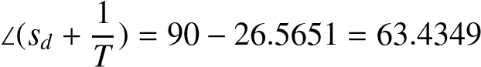

*To get the position of the pole, i.e:, we use the following trigonometric relation:*

 1 | | (*sd*)

= (*s*

*T*1 *d*) + tan(11.3099) = 2.2500

*which implies T*1 = 0.4444*. And from the relation a*1*T*1 = *, we get a*1 =

1.5002*.*

*2. for the design of the phase lag controller, notice that the compensated system with a phase lead controller has the following open transfer function:*

*s* + *a*11*T*1

*G*1(*s*) = *a*1*kKp* *s*(*s* + 2)*s* + *T*11

*with k* = 2*.*

*The root locus of this transfer function is illustrated by Fig. 5.22*

*The gain K*1 *that gives the poles that are close to the desired poles is given by:*

*K*1 = 3.87

*The corresponding poles are sd* = −1.5 ± 1.54*j with an overshoot approximatively equal to 5 %.*

*The error constant with this controller is given by:*

*s* + *a*11*T*1 1 *T*1

*K*2 = lim *sa*1*kKp*  = *a*1*kKp*  = *KP s*→0 *s*(*s* + 2)*s* + *T*11 *a*1*T*1 2



Root Locus

Real Axis

Imaginary Axis

−2.5

−2

−1.5

−1

−0.5

0

0.5

−6

−4

−2

0

2

4

6

0.04

0.09

0.14

0.2

0.28

0.4

0.56

0.8

0.04

0.09

0.14

0.2

0.28

0.4

0.56

0.8

1

2

3

4

5

1

2

3

4

5

*s*+ *a* 1*T*

**Fig. 5.22** Root locus of 1 1

*s*(*s*+2)*s*+ *T*11

*To get the desired error we need to fix Kp to 100. This gives the following parameter, a*2 *for the phase lag controller:*

*a*2 = *K*1 = 3.87 = 0.0387 *K*2 100



*Since the procedure for the design of the phase lag controller requires that we have to place the pole and the zero of the controller close each other and close to the origin. A proper choice consists of placing the zero at* −0.1*. This implies using the relation*

*p a*2 = 

*z*

*that the pole is placed at p* = −0.0039 *and since the pole is equal to:*

1

*p* = −

*T*2

*we get T*2 = 256.4103*.*

*The open loop transfer function of the system with the phase lead-lag controller is give by:*

*s* + *a*11*T*1

*G*2(*s*) = *a*1*kKp* 

*s*(*s* + 2)*s* + *T*11

*with k* = 2*.*

*The root locus of this transfer function is illustrated by Fig. 5.23*

Root Locus

Real Axis

Imaginary Axis

−2.5

−2

−1.5

−1

−0.5

0

0.5

−6

−4

−2

0

2

4

6

0.04

0.09

0.14

0.2

0.28

0.4

0.56

0.8

0.04

0.09

0.14

0.2

0.28

0.4

0.56

0.8

1

2

3

4

5

1

2

3

4

5

*s*+ *a*11*T*1 *s*+ *a*21*T*2

**Fig. 5.23** Root locus of 

*s*(*s*+2)*s*+ *T*11 *s*+ *T*12

*From this figure we get the closest poles of the desired ones are:*

*sd* = −1.5 ± 1.31*j*

*that gives an damping ratio about 0.753 and an overshoot equal to 2.73 %. The gain that gives this pair of poles is equal to:*

*K*¯*P* = 3.35

*From this data, we get the following gain for the controller:*

*K*¯*P* 3.35

*KP* = = = 28.8506 *a*1*a*2*k* 2 × 1.5002 × 0.0387



*The expression of the designed controller is given by:*

*s* + *a*11*T*1 *s* + *a*21*T*2



*C*(*s*) = *KP s* + 11 *s* + *T*12

*T*

*with KP* = 28.8506*,a*1 = 1.5002*,T*1 = 0.4444*,a*2 = 0.0387*and T*2 = 256.4103*.*

*The closed-loop transfer function with this controller is given by:*

*kKP a*1*T*1*a*2*T*2*s*2 + (*a*1*T*1 + *a*2*T*2)*s* + 1

*F*(*s*) = *b*4*s*4 + *b*3*s*3 + *b*2*s*2 + *b*1*s* + *b*0

*with b*4 = *T*1*T*2*, b*3 = (*T*1 + *T*2 + 2*T*1*T*2)*, b*2 = (1 + 2(*T*1 + *T*2) + *kKPa*1*T*1*a*2*T*2)*, b*1 = (2 + *kKP*(*a*1*T*1 + *a*2*T*2)) *and b*0 = *kKP.*

*The behavior of the closed-loop dynamics is illustrated in Fig. 5.24*

0

2

4

6

8

10

12

14

16

18

20

0

0.2

0.4

0.6

0.8

1

1.2

1.4

Step Response

Time (sec)

Amplitude

**Fig. 5.24** Step response of *F*(*s*)

*It seems that the settling time is a little bit far from the desired one. To overcome this, we play with the positions of the poles and the zeros of the controller and repeat the procedure.*

### 5.5 Design Based on Bode Plot

The design methods we will develop in this section have the advantage over those presented in the previous section by the fact they don’t need the knowledge of the mathematical model of the system to be controlled as it required by the techniques based on root locus method. The objective of this section is to cover the methods that we can use for designing the controllers treated in the previous section by using the frequency domain.

The design procedures for the different controllers we will cover here are mainly based on the fact to assure that the closed-loop dynamics of the system will have a phase margin, Δφ satisfying:

45*o* ≤ Δφ ≤ 50*o*

while the gain margin, Δ*G* satisfies Δ*G* ≥ 8 *db*.

In the rest of this section we assume that the system is described by the following transfer function:

*amsm* + · · · + 1 *G*(*s*) = *k*

*sl* (*ansn* + · · · + 1)

where *l* is the type of the system, *l* + *n* is the degree of the system and *m* < *n* + *l* is the degree of the numerator of the system that we suppose to be causal.

Our goal in this section consists of designing a controller that respond to some given performances. The controllers we consider in this section are those treated in the previous sections. It is important to notice that the idea used in the methods we will cover is based on the deformation of the magnitude and phase curves locally to satisfy the desired performances.

**Remark 5.5.1** *It is important to notice that this method doesn’t apply for unstable system.*

Let firstly consider the design of the proportional controller (*C*(*s*) = *KP*). This controller has limited actions and can only move vertically the magnitude curve without affecting the phase curve. The open loop transfer function of the compensated system is given by:

*amsm* + · · · + 1

*Gc*(*s*) = *kKP sl* (*ansn* + · · · + 1)

*amsm* + · · · + 1

= *K*

*sl* (*ansn* + · · · + 1)

The following procedure can be used for the design of the proportional controller that responds to the desired performances:

1. obtain the Bode plot for the compensated system, *Gc*(*s*), with *K* = 1
2. determine the frequency, *wc*, for which the phase margin is equal to 45*o*
3. determine the magnitude at this frequency and compute the gain, *K*¯*P* that will move the magnitude curve vertically to get the desired phase margin. A gain greater than one will move the magnitude curve up while a gain less than one will move it down. The controller gain is given by:

*K*¯*P*

*KP* = 

*k*

1. draw the Bode diagram of the compensated system, with the computed gain andcheck that the gain margin is greater than 8 *db*

**Example 5.5.1** *To show how the design procedure for the proportional controller works, let us consider the following dynamical system:*

2

*G*(*s*) = 

(0.1*s* + 1)(0.2*s* + 1)(0.5*s* + 1)

*The performances we would like to have for this system are:*

1. *stable system in closed-loop*
2. *phase margin about* 45*o*
3. *gain margin greater than* 10 *db*

*To design our proportional controller, let us follow the previous procedure.*

1. *the open loop transfer function of the compensated system, T*(*s*) *is given by:*

1

*T*(*s*) = 2*KP* 

(0.01*s* + 1)(0.2*s* + 1)(0.5*s* + 1)

1. *The Bode plot of this transfer function with K* = 1 *is illustrated in Fig. 5.25.*

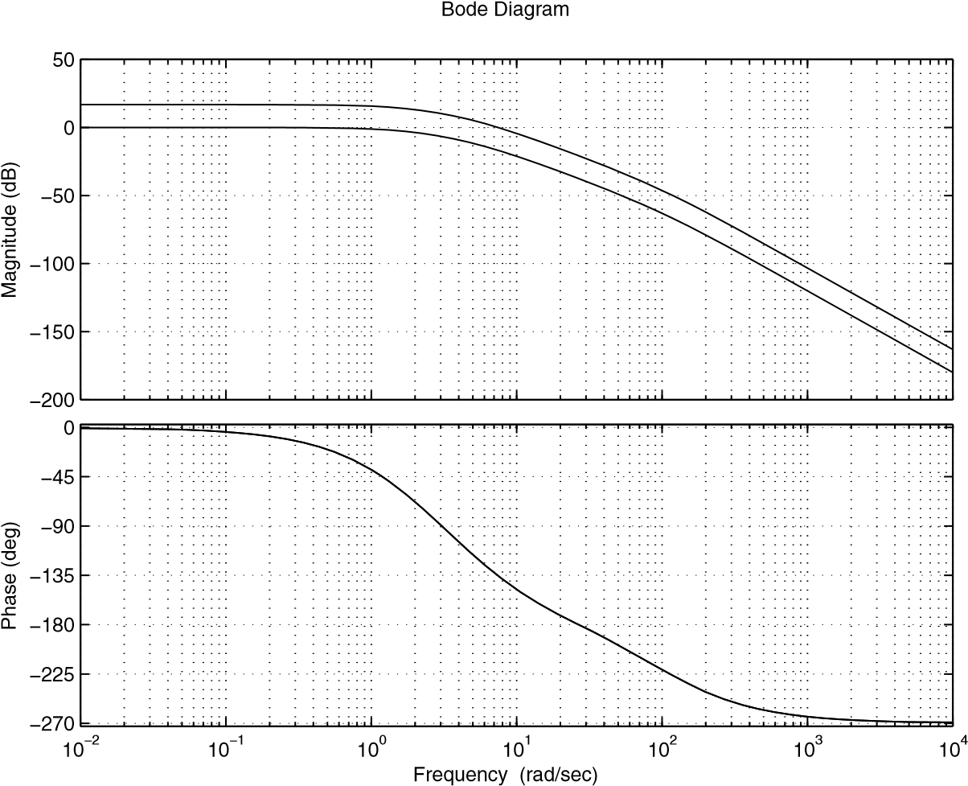

**Fig. 5.25** Bode plot of *T*(*s*), with *K* = 1, and *K* = *kKP*

*From this figure we conclude that at the frequency w*1 = 7.44 *rd*/*s we have* Δφ = 45*o. The corresponding magnitude is equal to* |*T*(*jw*1)| = −16.8*.*

1. *The corresponding gain that allows us to move the magnitude curve by* 16.8 *db to get the desired phase margin is given by:*

*K*¯*P* = 16.8 *db*

*which implies K*¯*P* = 10 1620.8 = 6.9183 *Finally, we get the controller gain as follows:*

*K*¯*P* 6.9183

*KP* = = = 3.4592 *k* 2



*The open loop transfer function of the compensated system is given by:*

1

*T*(*s*) = 2 × 3.4592

(0.01*s*+ 1)(0.2*s* + 1)(0.5*s* + 1)

*The Bode plot of this transfer function is reported in Fig. 5.25. If we compute the phase and the gain margins we get:*

Δ*G* = 10.8363

Δφ = 44.9849

*The corresponding frequencies are:*

*wg* = 26.65 *rd*/*s*,*for the gain margin wp* = 7.44 *rd*/*s*,*for the phase margin*

*4. The transfer function of the closed loop with this controller is given by:*

*kKP*

*F*(*s*) = 

0.001*s*3 + 0.107*s*2 + 0.71*s* + 1 + *kKP*

*with k* = 2*.*

*The behavior of the closed-loop dynamics is illustrated in Fig. 5.26*

*This response has a steady state error equal to* 0.13*. The proportionalcontroller is unableto make equal to zero but it can be reduced by increasing the gain. This may degrade the transient regime.*

**Remark 5.5.2** *It is important to notice that the system considered in the previous example is of type zero and therefore, the error for a step input with a proportional controller is constant and it is given by:*

*e*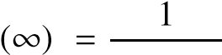.

1 + *kKp*

*From this expression, it is impossible to make the error equal to zero by increasing the gain of the controller. Incrementing the type of the system is a solution that can be given by the PI controller.*

Let us now focus on the design of the PI controller using the Bode method. As we have seen previously increase the type of the system by one and therefore, it may bring the steady state error to zero. Its disadvantage is that settling time may increase.

0

0.5

1

1.5

2

2.5

3

3.5

4

4.5

5

0

0.2

0.4

0.6

0.8

1

1.2

1.4

Step Response

Time (sec)

Amplitude

**Fig. 5.26** Step response of *F*(*s*)

To design the PI controller, let us assume that its transfer function is described by:

*KI*

*C*(*s*) = *KP* + 

*s*

1 + τ*ns*

= 

τ*is*

with *KP* = ττ*ni* and *KI* = τ1*i* .

Using this, the open loop transfer function of the compensated system is given by:

*bmsm* + · · · + *b*1*s* + 1

*T*(*s*) = *C*(*s*)*G*(*s*) = *K* (1 + τ*ns*) *sl*+1 (*ansn* + · · · + *a*1*s* + 1)

with *K* = τ*ki*

The following procedure can be used for the design of this controller:

1. determine the slowest pole that is not equal to those at the origin (pole that corresponds the highest time constant) and proceed with a zero/pole cancelation. This will allow us to determine the parameter τ*n* by:

τ*n* = max{τ1, · · · ,τν}

where τ*j*, *j* = 1, · · · ,ν are the time constant of the system to be controlled.

1. determine the gain *K*¯*P* that gives the desired phase margin using the Bode plot and obtain:

*k* τ*i* = 

*K*¯*P*

1. determine the gains *KP* and *KI* of the controller using: 1

|  |  |
| --- | --- |
| *KP* | =  τ*i* |
| *KI* | τ*n*  = |

τ*i*

1. determine the open loop transfer function of the compensated system and checkif the desired performances are obtained or not. In case of negative response adjust τ*n* and repeat the procedure design.

**Example 5.5.2** *To show how this procedure works let us consider the following dynamical system:*

1

*G*(*s*) = 

(*s* + 1)(*s* + 5)(*s* + 10)

*and design a PI controller that gives a steady error equal to zero and a phase margin about* 45*o and a gain margin greater than* 8 *db.*

*To answer these performances, let us follow the previous procedure:*

1. *the open transfer function of the system to be controller has* 1*,* 0.2 *and* 0.1 *as time constants. The maximum one is equal to* 1 *and therefore by canceling the corresponding pole by the controller’s zero, we get:*

τ*n* = 1 *s*

1. *the open loop transfer function with the pole*/*zero cancellation is given by:*

0.02*K*

*T*(*s*) = 

*s*(0.2*s* + 1)(0.1*s* + 1)

*The Bode plot of this transfer function is shown at Fig. 5.27*

*At w* = 2.8 *rd*/*s, the phase margin is equal to* 45*o and at this frequency the magnitude is equal to* −10.5 *db. To get such phase margin we need to translate up the magnitude curve by* 17.5 *db which implies the use of a gain:*

*K*¯*P* = 10 = 3.3497

*which implies in turn:*

0.02

τ*i* =  = = 0.0060

*K*¯*P* 3.3497

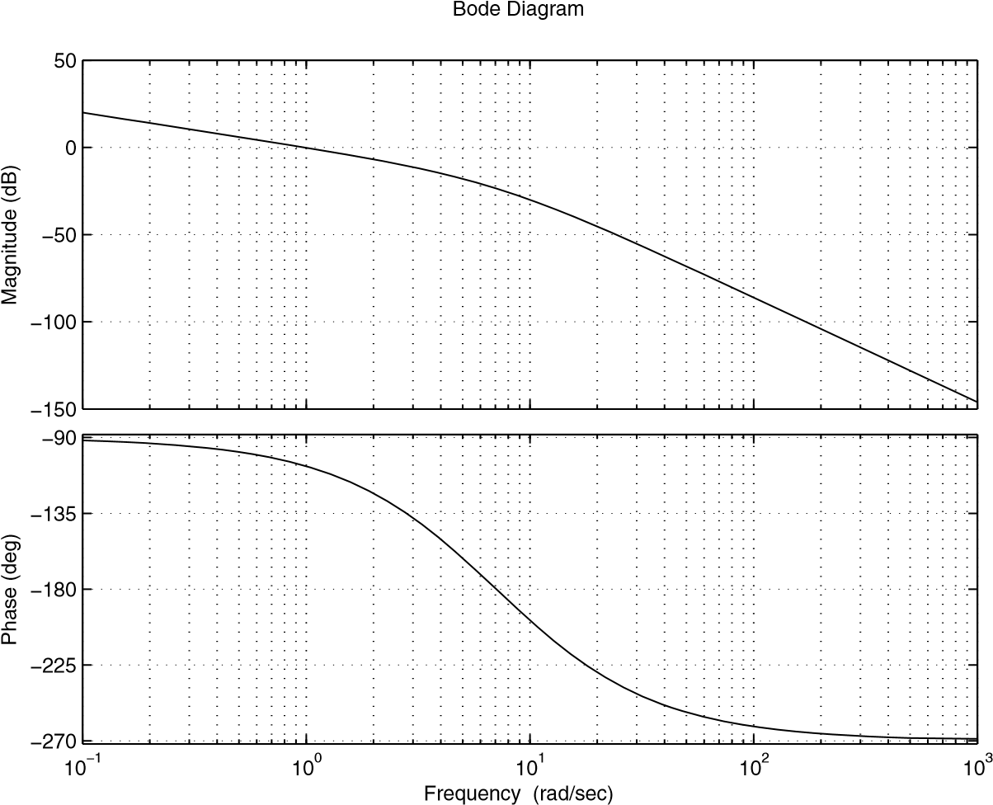

**Fig. 5.27** Bode plot of *T*(*s*), with *K* = 1

1. *the controller gains are given by:*

1 1

*KP* = = = 166.6667 τ*i* 0.0027 τ*n* 1



*KI* = = = 166.6667 τ*i* 0.0027



1. *with this controller we can check that the phase margin is equal to* 45.1*o but the gain margin is equal to* 4.5 *db. The closed loop transfer function with this controller is given by:*

*KP*

*F*(*s*) = *s*3 + 15*s*250*s* + *KP*

*If we accept the gain margin as it is now, the design is complete otherwise we have to modify the value for* τ*n and repeat the design*

*The behavior of the closed-loop dynamics with the computed controller is illustrated in Fig. 5.28*

*The settling time at 5 % is equal to* 1.47 *s which is acceptable and the error for a step input is equal to zero.*

Let us now focus on the design of the PD controller using the Bode method. This controller improves the transient regime. The transfer function of this controller is given by:

Step Response

Time (sec)

Amplitude

0

0.5

1

1.5

2

2.5

3

3.5

4

4.5

5

0

0.2

0.4

0.6

0.8

1

1.2

1.4

**Fig. 5.28** Step response of *F*(*s*)

*C*(*s*) = *KP* + *KDs* = *KP* (1 + τ*Ds*)

with τ*D* = *KKDP* .

The open loop transfer function of the compensated system is given by:

(1 + τ*Ds*)(*bmsm* + · · · ,*b*1*s* + 1)

*T*(*s*) = *K* 

*sl* (*ansn* + · · · ,*a*1*s* + 1)

where *K* = *kKP*

The design of the PD controller is brought to the determination of the two gains *KP* and *KD*. The following procedure can be used for the design of this controller: 1. from the error specifications, determine the gain, *K*¯*P* that gives the desired error 2. draw the Bode diagram of the system:

*K*

¯*P slb*(*mansmsn*++· · ·· · ·,,*ba*11*ss*++11)

and determine the frequency, *wm* at the which the magnitude is equal to −20 *db*

3. since the cut frequency of the PD controller is equal to τ1*D* , at the frequency

#### 10

τ*D* , the contribution of the PD controller to the magnitude and the phase are respectively 20 *db* and 90*o*. If we select τ*D* such that:

10 τ*D* = *wm*

the phase margin of the compensated system is given:

Δφ*c* = Δφ + 90

where Δφ is the phase margin of the system without the controller at the frequency *wm*

If

Δφ*c* ⎧⎪⎪⎨⎪> 50*o* reduce the parameter, τ*D* till Δφ*c* = 45*o* < 40*o* choose another controller

⎪⎩

1. compute the controller’s gains using:

*K*¯*P*

*KP* = 

*k*

*KD* = *K*¯*P*τ*D*

1. check if the desired specifications are obtained or not

**Example 5.5.3** *To show how the procedureof the designof the PD controller works, let us consider the following dynamical system:*

4

*G*(*s*) = 

*s*(0.1*s* + 1)(4*s* + 1) *As specifications we consider the following:*

1. *stable system*
2. *phase margin equal to* 45*o*
3. *steady state error equal to 0.1*

*To satisfy these specifications a PD controller has to be designed. For this purpose let is follow the previous procedure:*

1. *from the error specification, we need to fix K*¯*P to 10.*
2. *the Bode diagram of:*

*K*¯*P*



*s*(0.1*s* + 1)(4*s* + 1)

*is illustrated by Fig. 5.29 which shows that magnitude is equal to* −20 *db when the frequency wm* = 4.73 *rd*/*s. The parameter* τ*D is then given by:*

10 10 τ*D* = = = 2.1142 *wm* 4.73



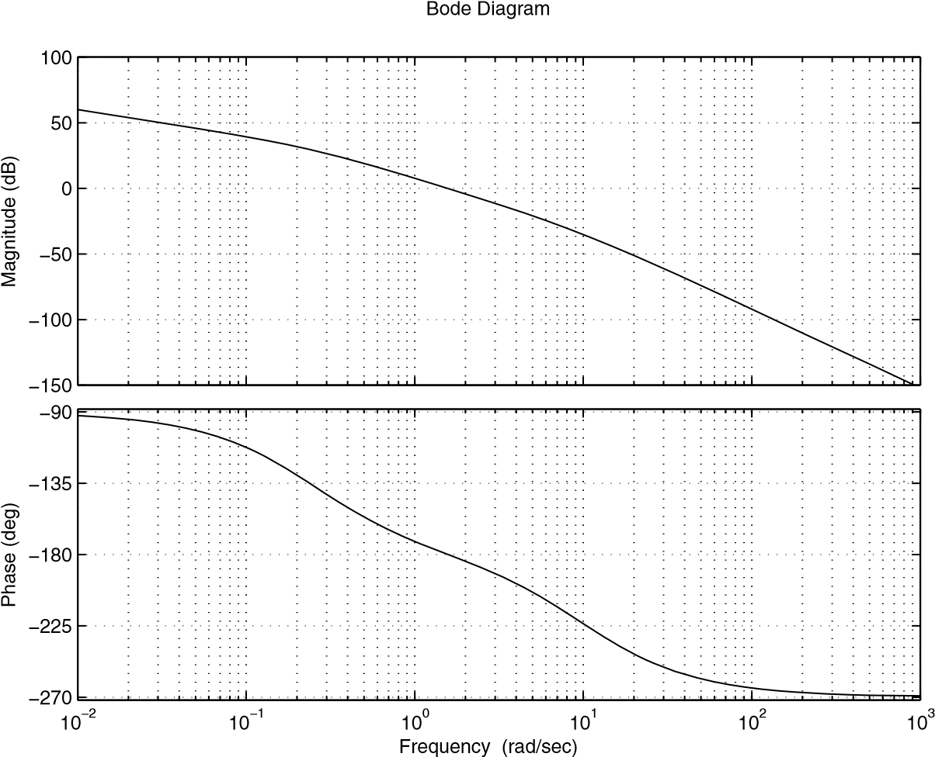

**Fig. 5.29** Bode plot of *T*(*s*), with *K* = 10

1. *the phase of the system with the controller at wm* = 4.73 *rd*/*s is equal to* −202*o. The phase margin of the compensated system is given by:*

Δφ*c* = 180 − 202 + 90 = 68*o*

*The phase margin is greater than* 45*o and we should decrease the parameter* τ*D. Therefore if we select* τ*D* =  = 1.0989*, the phase margin in this case is equal to* 49*o*

1. *the controller gains are give by:*

*K*¯*P* 10

*KP* = = = 2.5 *k* 4



*KD* = *K*¯*P*τ*D* = 2.4 × 1.0989 = 2.7473

1. *the open loop transfer function of the compensated system is given by:*

4(*KP* + *KDs*)

*T*(*s*) = 

*s*(0.1*s* + 1)(4*s* + 1)

*This controller gives a phase margin about* 61.5*o. The closed-loop transfer function is given by:*

4(*Ks* + *Kp*)

*F*(*s*) = 

0.1*s*3 + 4.1*s*2 + (1 + 4*KD*)*s* + 4*KP*

*The step response of the compensated system is represented in Fig. 5.30.*

0

0.5

1

1.5

2

2.5

3

3.5

4

4.5

5

0

0.2

0.4

0.6

0.8

1

1.2

1.4

Step Response

Time (sec)

Amplitude

**Fig. 5.30** Step response of *F*(*s*)

Let us now focus on the design of the PID controller using the Bode method. This controller acts on the transient and steady state regimes. The transfer function of this controller is given by:

*KI* (1 + τ*ns*)(1 + τ*vs*) *C*(*s*) = *KP*  + *KDs* = 

*s* τ*is*

where *KP* = τ*n*τ+*i*τ*v* , *KI* = τ1*i* and *KD* = τ*n*ττ*i v* .

The open loop transfer function of the compensated system is given by:

(1 + τ*ns*)(1 + τ*is*)(*bmsm* + + *b*1*s* + 1)

*T*(*s*) = *K* · · ·

*sl*+1 (*ansn* + · · · + *a*1*s* + 1)

with *K* = τ*ki* .

To design such controller we use the ideas used to design separately the PI and the PD controllers. The procedure to design such controller is based on the fact that a pole is introduced at the origin, the gain, *K*¯*P* that gives the steady error and the use of the maximumphase, 90*o* (introducedby the PD controller)that correspondsto the frequency when the magnitude is to −20 *db* (*wm*τ*v* = 10). The following procedure can be used for the design of this controller:

1. determine the slowest pole of the system to controller except those at the originand proceed with a pole/zero cancellation. This will help to fix, τ*n*, i.e.:

τ*n* = max{τ1, · · · ,τν}

1. determine the gain *K*¯*P* that gives the desired error 3. plot the Bode diagram of:

¯*P* (1 +*sl*+τ1*ns*(*a*) *n*(*bsnm*+*sm*· · ·+ · · ·+ *a*+1*sb*+1*s*1+) 1)

*T*(*s*) = *K*

and determine the frequency *wm* at which the magnitude is equal to −20 *db*.

Using this frequency we determine τ*v* by:

10 τ*v* = *wm*

the phase margin of the compensated system is given:

Δφ*c* = Δφ + 90

where Δφ is the phase margin of the system without the controller at the frequency *wm*

If

Δφ*c* ⎧⎪⎪⎨⎪> 50*o* reduce the parameter, τ*D* till Δφ*c* = 45*o* < 40*o* choose another controller

⎪⎩

1. compute the controller’s gains using:

τ*n* + τ*v*

*KP* = 

τ*i*

1

*KI* = 

τ*i* τ*n*τ*v*

*KD* = 

τ*i*

1. check if the desired specifications are obtained or not

**Example 5.5.4** *To show how the design of the PID controller works, let us consider the following dynamical system:*

2

*G*(*s*) = 

(0.1*s* + 1)(0.2*s* + 1)(0.5*s* + 1)

*A steady state error to a unit ramp equal 0.1 is needed.*

*This system is of type zero and has three time constant,* 0.5*,* 0.2 *and* 0.1*. The maximum time constant is* 0.5*.*

*Following the procedure design, we get:*

1. *using the maximum time constant of the system we have:*

τ*n* = 0.5

1. *using the error specification, we get:*

|  |  |
| --- | --- |
| *K*¯*P*  *3. draw the Bode diagram of:* | =  = 10  0.1 *K*¯*P* |

1

*T*(*s*) = 

*s*(0.1*s* + 1)(0.2*s* + 1)

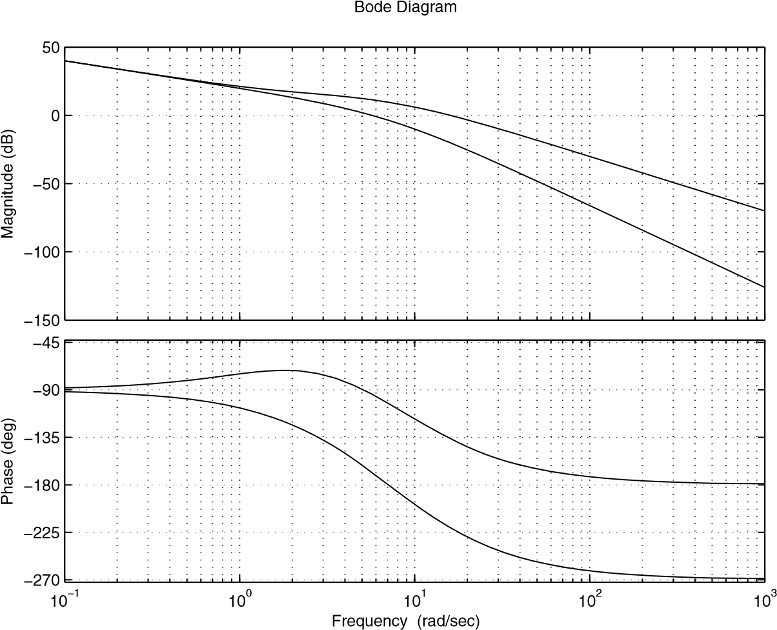

**Fig. 5.31** Bode plot of *T*(*s*)

*This diagram is illustrated by Fig. 5.31. The frequency at which the magnitude is equal to* −20 *db is equal to wm* = 15.9*. The phase at this frequency is equal to* −220*o. The phase margin at this frequency is given by:*

Δφ = 180 + φ(*wm*) + 90 = 180 − 220 + 90 = 50

*The second parameter,* τ*v of the controller is determined by:*

10

τ*v* =  = 0.6289 *wm*

1. *compute the controller’s gains using:*

|  |  |
| --- | --- |
| τ*i* | 2  =  = 0.2  10 |
| *KP* | τ*n* + τ*v*  =  = 5.6447  τ*i* |
| *KI* | 1  =  = 5 τ*i* |
| *KD* | τ*n*τ*v*  =  = 1.5723 |

τ*i*

1. *The closed-loop transfer function with this controller is given:*

2 τ

τ*i* ( *vs* + 1) *F*(*s*) = 

0. τ*i s* + τ2*i*

*The step response of the compensated system is represented in Fig. 5.32.*

Step Response

Time (sec)

Amplitude

0

0.2

0.4

0.6

0.8

1

1.2

1.4

1.6

1.8

2

0

0.2

0.4

0.6

0.8

1

1.2

1.4

**Fig. 5.32** Step response of *F*(*s*)

Let us now focus on the design of the phase-lead controller using the Bode method. The transfer function of this controller is given by:

*aTs* + 1

*C*(*s*) = *KP* ,*a* > 1

*Ts* + 1

It can be shown that this controller can be deliver a maximum of phase for each value for *a*. The value of this maximum and the frequency at which this happens are given by:

*wm* √

*T a*

*a* 1

 sin(φ*m*) = −

*a* + 1

The second relation gives also:

1 + sin(φ*m*) *a* = 

1 − sin(φ*m*)

These relations are of great importance in the design procedure of the phase-lead controller.

The following procedure can be used for the design of this controller:

1. using the error specification, determine the gain *K*¯*P* and compute the controller gain by:

*K*¯*P*

*K*¯*P* = 

*k* 2. plot the Bode diagram of:

*K*¯*P* *slb*(*mansmsn*++· · ·· · ·++*ba*11*ss*++11)

and determinethe phase andgain marginsof the non-compensatedsystem. Then compute the phase margin missing. This value increased by a factor (5*o*) for safety is considered as φ*m*, then compute the parameter *a* by:

1 + sin(φ*m*) *a* = 

1 − sin(φ*m*)

1. determine the frequency, *wm* for which the magnitude of the non-compensated system is equal to −20log √*a* and consider it as the crossover of the compensated system. The parameter *T* of the controller is determined using:

*T* √

*wm a*

1. check if the desired specifications are obtained or not

**Example 5.5.5** *Let us consider the following dynamical system:*

5(0.125*s* + 1)

*G*(*s*) = 

*s*(2*s* + 1)(0.1*s* + 1)

*Our objective in this example is to design a phase-lead controller satisfies the following specifications:*

1. *stable system*
2. *steady state error for a ramp input equal to 0.1*
3. *phase margin greater than* 40*o*
4. *gain margin greater than* 6 *db*

*The design of the phase-lead controller is brought to the determination of the parameters a and T. To accomplish this, we follow the previous procedure.*

1. *since the system is of type one, therefore the error for a ramp input is given by:*

*e*

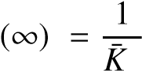*P*

*which gives in turn:*

*K*¯*P* = 10

*which gives:*

*K*¯*P*

*KP* =  = 2

*k*

1. *with this gain, the open loop transfer function of the system becomes:*

10

*T*(*s*) = 

*s*(2*s* + 1)(0.1*s* + 1)

*The Bode diagram of this system is given by Fig. 5.33.*

*From this diagram we conclude that the system with a proportional controller has a phase margin equal to* 15.67*o and a gain margin equal to* ∞ *db. To get our desired phase margin we need to add* 24.33*o. If we take a* 5*o safety, the controller should add a phase,* φ*m equal to* 29.33*o. This gives:*

1 + sin(29.33)

*a* =  = 2.9201

1 − sin(29.33)

1. *with this value of a we have:*



*From 5.33, we remark that the magnitude curve takes* −4.6540 *at the frequency wm* = 2.93 *rd*/*s. This gives:*

*T* √

*wm a*

*The controller is then given by:*

*aTs* + 1 0.5832*s* + 1

*C*(*s*) = *KP* = 2



*Ts* + 1 0.1997*s* + 1

*The open loop transfer function of the compensated system is given by:*

0.5832*s* + 1

*T*(*s*) = 10

*s*(2*s* + 1)(0.1*s* + 1)(0.1997*s* + 1)

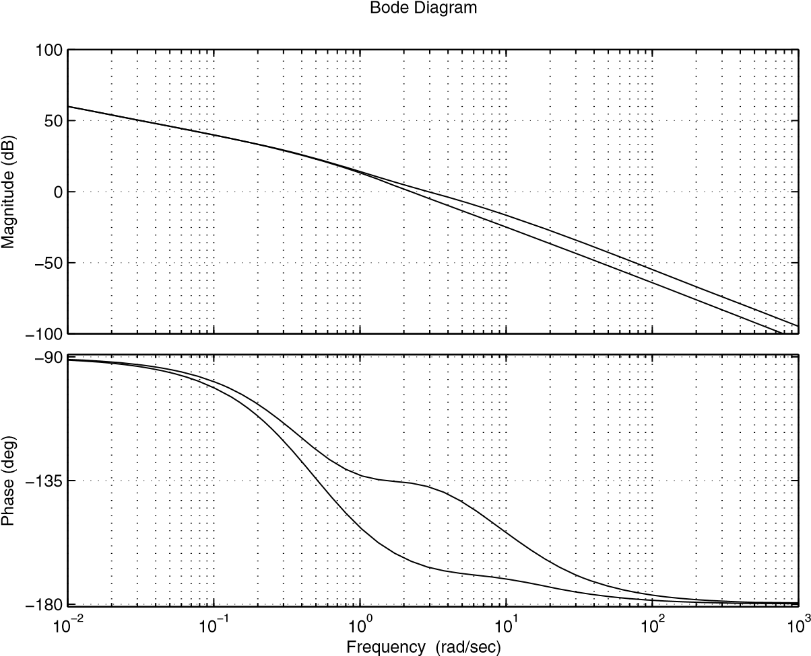

**Fig. 5.33** Bode plot of *T*(*s*)

1. *with controller we get* 42.8*o and* ∞ *db as phase margin and gain margin respectively.*

*The closed-loop transfer function is given by:*

*kKP* 0.125*aTs*2 + (0.125 + *aT*)*s* + 1 *F*(*s*) = *b*4*s*4 + *b*3*s*3 + *b*2*s*2 + *b*1*s* + *b*0

*with k* = 5*, b*4 = 0.2*T, b*3 = 0.2 + 2.1*T, b*2 = 2.1 + *T* + 0.125*aTkKP, b*1 = 1 + *akKP*(0.125 + *aT and b*0 = *kKP.*

*The behavior of the closed-loop dynamics with the computed controller is illustrated in Fig. 5.34*

*The settling time at 5 % is equal to* 1.68 *s which is acceptable and the error for a step input is equal to zero while the overshot is about 30 %.*

Let us now focus on the designof the phase-lagcontrollerusing the Bode method. The transfer function of this controller is given by:

*aTs* + 1

*C*(*s*) = *KP* ,*a* < 1

*Ts* + 1

0

0.5

1

1.5

2

2.5

3

3.5

4

4.5

5

0

0.2

0.4

0.6

0.8

1

1.2

1.4

Step Response

Time (sec)

Amplitude

**Fig. 5.34** Step response of *F*(*s*)

The following procedure can be used for the design of this controller:

1. using the error specification, determine the gain *K*¯*P* and compute the controller gain by:

*K*¯*P*

*K*¯*P* = 

*k* 2. plot the Bode diagram of:

*K*

¯*P slb*(*mansmsn*++· · ·· · ·++*ba*11*ss*++11)

and determine the frequency, *wm* of the non-compensated system at which we have the desired phase margin. Then compute of how much decibels, *m* to bring the magnitude to 0 *db* at *wm*.The parameter *a* of the controller is given by:

*m a* = 1020

1. To get an appreciable change the phase curve, we need to choose, the parameter,*T* as follows:

10

*T* = 

*awm*

1. check if the desired specifications are obtained or not

**Example 5.5.6** *Let us consider the following dynamical system:*

2

*G*(*s*) = 

*s*(0.1*s* + 1)(0.05*s* + 1)

*Our objective in this example is to design a phase-lag controller satisfies the following specifications:*

1. *stable system*
2. *steady state error for a ramp input equal to 0.1*
3. *phase margin greater than* 40*o*
4. *gain margin greater than* 4 *db*

*The design of the phase-lag controller is brought to the determination of the parameters a and T. To accomplish this, we follow the previous procedure.*

1. *the system to be controlled is of type one. The steady error to a unit ramp asinput is given by:*

*e*

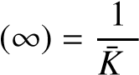*P*

*which implies:*

*K*¯*P* = 10

*From this we conclude that the gain of the controller is KP* = 5*.*

1. *with this gain, the open loop transfer function of the system becomes:*

10

*T*(*s*) = 

*s*(0.1*s* + 1)(0.05*s* + 1)

*The Bode diagram of this system is given by Fig. 5.35.*

*From this figure, we conclude, that at wm* = 5.59 *rd*/*s, the phase margin is equal to* 45*o. At this frequency the magnitude is equal to* 3.52 *db. Using this, the parameter, a is given bY:*

*a* = 10−320.52 = 0.6668

***Remark 5.5.3*** *The fact that we consider* −3.52 *db means that we want the controller to introduce this amplitude at this frequency.*

1. *the choice of T is done by placing the frequency aT*1 *at a decade from wm* =

5.59 *rd*/*s, i.e.:*

10 *wm* = 

*aT*

*which implies T* = 2.6828*.*

*The transfer function of our phase-lag controller is given by:*

*aTs* + 1 *C*(*s*) = *KP* 

*Ts* + 1

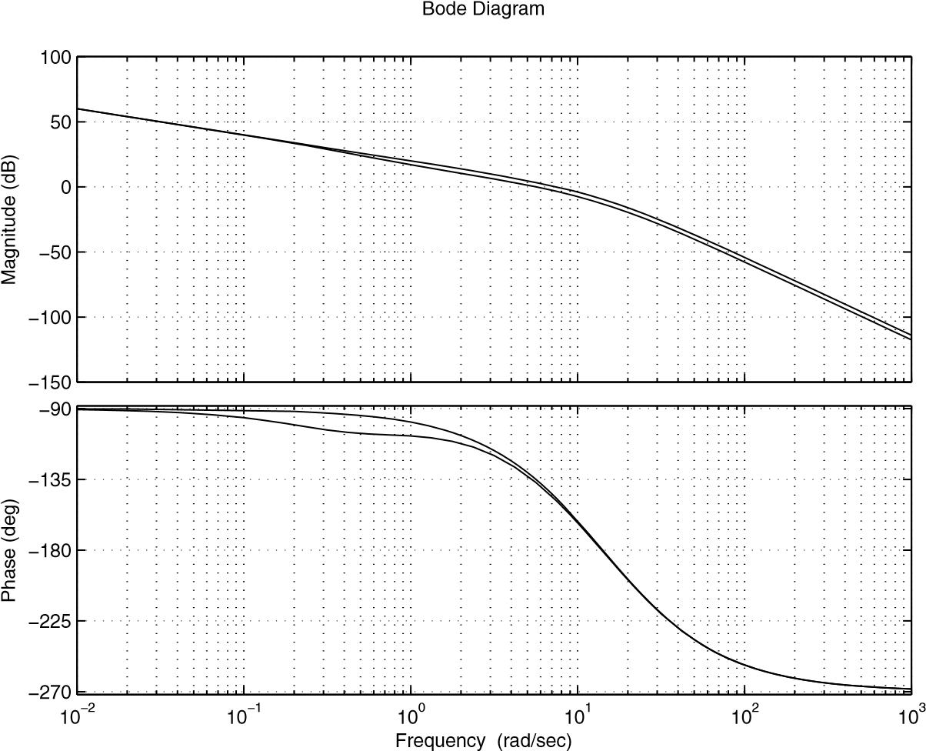

**Fig. 5.35** Bode plot of *T*(*s*)

*with KP* = 5*.*

*With this controller we get:*

Δφ = 43.13*o*

Δ*G* = 4.37 *db*

*The closed-loop transfer function is given by:*

*kKP* (*aTs* + 1)

*F*(*s*) = 

0.005*Ts*4 + (0.005 + 0.15*T*)*s*3 + (0.15 + *T*)*s*2 + (1 + *kKPaT*)*s* + *kKP with k* = 2*.*

*The behavior of the closed-loop dynamics with the computed controller is illustrated in Fig. 5.36*

*The settling time at 5 % is equal to* 0.78 *s which is acceptable and the error for a step input is equal to zero while the overshot is about 27 %.*

Let us now focus on the design of the phase lead-lag controller using the Bode method. The transfer function of the controller is given by:

*C*(*s*) = *KP a*1*T*1*s* + 1 *a*2*T*2*s* + 1,*a*1 > 1,*a*2 < 1



*T*1*s* + 1 *T*2*s* + 1

The following procedure can be used for the design of this controller:

Step Response

Time (sec)

Amplitude

0

0.5

1

1.5

2

2.5

3

3.5

4

4.5

5

0

0.2

0.4

0.6

0.8

1

1.2

1.4

**Fig. 5.36** Step response of *F*(*s*)

1. using the error specification, determine the gain *K*¯*P* and compute the controller gain by:

*K*¯*P*

*K*¯*P* = 

*k* 2. draw the Bode diagram of:

*K*

¯*P slb*(*mansmsn*++· · ·· · ·++*ba*11*ss*++11)

and determine the phase margin of the non-compensated system

1. determine the phase-lead controller’s parameters, *a*1 and *T*1
2. determine the phase-lag controller’s parameters, *a*2 and *T*2
3. check if the desired specifications are obtained or not

**Example 5.5.7** *To show how to design a phase lead-lag controller let us consider the following dynamical system:*

4(0.125*s* + 1)

*G*(*s*) = 

*s*(0.1*s* + 1)(0.2*s* + 1) *As specifications we search to get the following ones:*

1. *stable system*
2. *steady state error to a unit ramp equal to 0.05*
3. *a phase margin greater than* 40*o*
4. *a gain margin greater than* 8 *db*

*To design the phase lead-lag controller let us follow the steps of the previous procedure.*

1. *to get the desired error a gain K*¯*P equal to 20, which corresponds to KP* = 5*.*
2. *The transfer function of the open loop of the non compensated system with thisgain is given by:*

20(0.125*s* + 1)

*T*(*s*) = 

*s*(0.1*s* + 1)(0.2*s* + 1)

*The Bode diagram of this system is given by Fig. 5.37.*

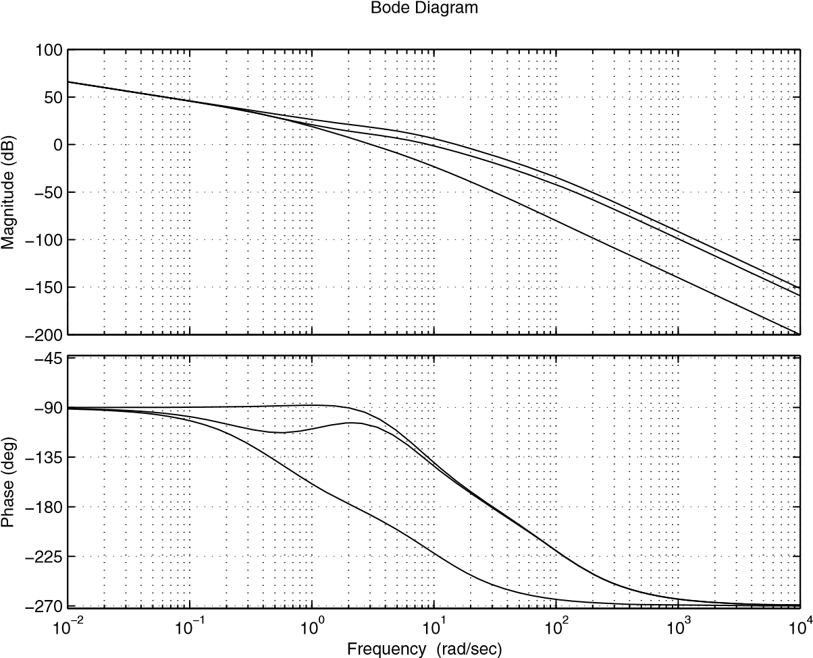

**Fig. 5.37** Bode plot of *T*(*s*)

*With this proportional controller the system has:*

Δφ = 32.7*o*

Δ*G* = ∞ *db*

1. *to design the phase-lead controller can be done following the previous procedure for this purpose. Notice that to get the desired phase margin, the phase-lead controller must bring a phase of* 45*o* − 32.7*o* = 12.3*o. Using this, we have:*

*a*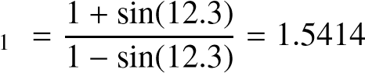

*Using the value of a*1*, we get:*



*Now if we refer to the Fig. 5.37, the magnitude will have* −1.8791 *at the frequency wm* = 11.4 *rd*/*s. This implies:*

*T* 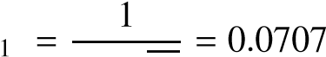√

*wm a*1

*The transfer function of the phase lead controller is given:*

0.4231*s* + 1 *C*(*s*) = 

0.0707*s* + 1

*The open loop transfer function of the system with controller is given by:*

*a*1*T*1*s* + 1

*T*(*s*) = 20 *s*(0.2*s* + 1)(0.01*s* + 1)(*T*1*s* + 1) *4. the system compensated with the phase lead controller has:*

Δφ = 10.9624*o*

Δ*G* = ∞ *db*

*To get a phase margin equal to* 45*o and if we report to the Fig. 5.37, we have this at the frequency wm* = 10 *rd*/*s. Also at this frequency, the magnitude is equal to 1.76 db. using this we get the parameter a*2 *for the phase lag controller:*

*a*2 = 10−120.76 = 0.8166

*The choice of T*2 *is given by:*

10 

*T*2 =  == 2.6542 *wma*2 9.07 × 0.4154

*The transfer function of the phase lead controller is given:*

1.1026*s* + 1 *C*(*s*) = 

2.6542*s* + 1

*5. The open loop transfer function of the compensated system is given by:*

*T*(*s*) = 20 (*a*1*T*1*s* + 1)(*a*2*T*2*s* + 1)(0.125*s* + 1)



*s*(0.2*s* + 1)(0.1*s* + 1)(*T*1*s* + 1)(*T*2*s* + 1)

*The Bode diagram of this transfer function is reported in Fig. 5.37 and from which we get:*

Δφ = 44.1*o*

Δ*G* = ∞ *db*

*The closed-loop transfer function of the compensated system*

α3*s*3 + α2*s*2 + α1*s* + α0



*F*(*s*) = *kKP b*5*s*5 + *b*4*s*4 + *b*3*s*3 + *b*2*s*2 + *b*1*s* + *b*0

*with* α3 = 0.125*a*1*a*2*T*1*T*2*,* α2 = 0.125(*a*1*T*1 + *a*2*T*2) + *a*1*a*2*T*1*T*2*,* α1 = 0.125+ *a*1*T*1 + *a*2*T*2 *and* α0 = 1*; b*5 = 0.02*T*1*T*2*, b*4 = 0.3*T*1*T*2 + 0.02(*T*1 + *T*2)*, b*3 = 0.02 + *T*1*T*2 + 0.3(*T*1 + *T*2) + 0.125*kKPa*1*a*2*T*1*T*2*, b*2 = 0.3 + *T*1 + *T*2 + *kKP*(0.125(*a*1*T*1 + *a*2*T*2) + *a*1*a*2*T*1*T*2)*, b*1 = 1 + *kKP*(0.125 + *a*1*T*1 + *a*2*T*2) *and b*0 = *kKP*